Careers Project: Film Production

Career Outline:

A producer is someone who is in charge of overseeing the creation of a film, television, radio broadcasts, music album, or theatre performances. They are responsible for seeing a production through from beginning to end. They are in charge of many administrative aspects such as overseeing cast and crew, hiring, writing, maintaining a budget, editing content, and creating work schedules. They insure that various productions meet goals. A producer can be in charge of coming up with new projects, initiating and entering into negotiations with whoever owns the sourced material, with the end goal being to acquire the rights on their terms.
Responsibilities:
- Read, research and assess ideas and finished scripts.
- Build and develop a network of contracts.
- Raise funding.
- Control the budget and allocate resources.
- Maintain technical skills.
- Organize shooting schedules/
- Troubleshoot.
- Have regular meetings with the director to discuss characters and scenes.
- Pull together all the strands of creative and practical talent involved in the project to make a good team.
- Make sure the end project has been completed on budget.
- They need strong communication and negotiation skills.
- Excellent organization.
- Ability to deal with a large range of people.
- String leadership and motivational skills.
- String financial and administrative skills.
- Ability to coordinate the work of a large group of people.

Courses Available at Colleges + Entry Requirements:

PLC Colleges:
- Pulse College, Dublin. This college will help you reach your goals whether you aspire to be an editor, screenwriter, cinematographer, director, producer, or sound recordist. They have highly qualified professionals who use industry standard software and make the courses practically based. This will help prepare you for a workplace and to advance your skills.
Courses Offered:
- BA in Film and Television Production (3 Year Degree Full Time). “Using the industry standard software and studio equipment available at Windmill Lane Recording Studios, you will work with our professional lecturing staff and industry guest speakers to develop a combination of practical skills, underpinned by theoretical lectures and tutorials. Program modules and content will evolve to reflect educational developments”.
Admission Requirements: Must apply through the CAO system. Must achieve a minimum of 5 O6/H&s (O6: 40-55% in a leaving certificate ordinary subject / H7 = 30-40% in leaving certificate higher level subjects. Must have a proven interest in film and in related creative media arts.
- Full Time Diploma in Film Production (1year full time): One of the most respected courses of its type in Ireland. In this course you will learn a variety of technical and creative production skills. You are challenged to produce a large variety of quality work such as commercial productions, documentaries, etc.
Admission Requirements:
This course is a direct application course which includes an interview. It is necessary to have an interest in the industry and basic knowledge of computers
- Dun Laoghaire Further Education Institute: A 1 years PLC course which is full time and is an excellent foundation for Film and television degrees.
Entry Requirements:
- Leaving Certificate Established/ LCVP
- Leaving Certificate Applied
- Relevant Level 4 QQI Award
- DIT: Bachelor of Arts (Hons) Film & Broadcasting:
- Undergraduate Level 8.
- 4 years full time.
- Film and broadcasting is all about telling stories whether they are fiction or factual. It combines high standards of production skill training with a solid academic education in media theory and contextual studies. While the core focus is traditional media, the programme will also study new media forms which both require the same skill sets. This looks like a really good course because it covers all areas such as film and media literacy, intro to film theory, intro to media theory, world cinema, still image, writing, animation, audio production, popular culture, television production, and many more. This is a course that really appeals to me because it covers so many areas of film. If I was to do this course, after college I could specialize on an individual part of the course more in depth such as television production. They also offer a year abroad which would be a great experience for me to understand what the industry is really like.
Entry Requirements:
- 2017 CAO Points: 437
- Minimum # of Subjects: 6
- Minimum # of Honors: 2H5’s
- At least a H4 in English
- A QQI/PLC Level 5 entry route is also available.
- Maynooth University: Department of Media Studies.
Undergraduate degree level 8. Students in this course gain experience in critical analysis and media production with the tools available to engage in media research and production across the public sector and private industry. They offer and BA in media Studies (combining critical studies with digital practice and TV production) and an MA in Critical and Creative Media. They also offer a MLitt and PhD research degrees.
Entry Requirements:
- CAO Points: 331
- H5 in English
- O6/H7 in language

Suitable Leaving Cert Subjects for Film Production

I think that out of all leaving cert subjects that are available, I should strive to get the highest points in:
- English
- Language
- Art
English would be beneficial for film production because it could help you become a better writer. This would help your script-writing skills. It is also necessary to learn all of the vocabulary related to film-making so that you fully understand the career.
Learning a language could be extremely beneficial for a career. This is because it could open up many new opportunities such as studying abroad or eve working abroad. Often people who speak more than one language are very in demand as they would be able to speak to some foreign clients and earn more business.
Art would be another key subject for film production. This is because many artistic decisions are needed in this industry. For example, you can help come up with set design plans, design covers, etc. It could also open up opportunities in the animation industry. I don’t currently study Art in school but this may b something that I should consider

Possible Leaving Cert Outcomes:

Subjects I Plan to Take:
English: I would like to do honors English because I have a passion for it. If I study hard enough I believe I would be able to achieve a high H3 or a low H2.
History: I also have a passion for history so I believe I would be able to get a high H3 or a low H2.
Maths: Maths is not a strong point for me but I would still like to take honors in order to get the most points possible in my leaving cert. Since this is not one of my strong subjects I would realistically end up getting a H5/H4 if I make sure to study really hard.
Business: I have just started business this year so it is difficult for me to know the possible outcome of this grade. This is because I do not know the difficulty of this subject or if I am truly interested in it yet.
Biology: Biology is another subject that I am not particular strong at. I believe this is because I have a general dislike towards the subject, causing a lack in motivation. I aim to take this class in honors and think that with a lot of hard work I could get a H3.
Spanish: I am passionate about Spanish so I am definitely going to take this class in honors. I believe that I would be able to achieve a H2 in this subject.

When looking at my interests in terms of subjects it is easy to see that I prefer subjects that require more language usage compared to subjects that are science/maths related. This is why I think being a film producer would suit me most.

Interests Test
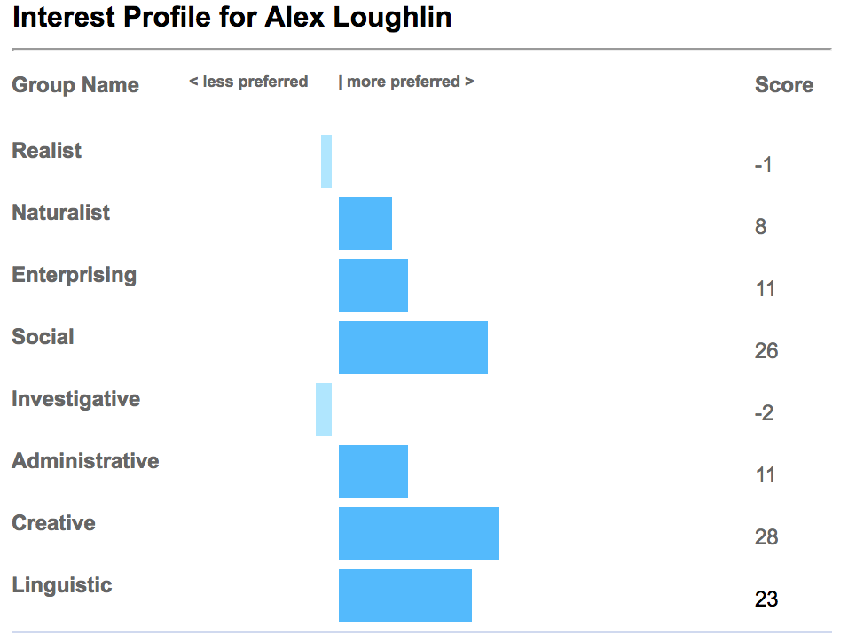

From this test I have realized that I am mostly creative, linguistic, and social. I was happy that this was my results as these are the types of people that would be most acceptable for a career in film.

Creative: "I like work that allows me to express my ideas or imagination. I like a flexible workplace where there is room to develop and expand my creativity". This quote really described the type of job I would like. This is because I would prefer a job where the daily schedule always changes, rather than doing the same thing in the same place every day. I also consider myself to be quite creative in terms of coming up with new ideas. A job that allowed me to flourish and improve in a particular profession would be ideal for me.

Linguistic: "I like work that involves speaking or writing about things. I like the opportunity to express myself through discussion and debate, and communicating using a variety of media." This also perfectly describes me because I have a passion for English literature and also Spanish. I also love debating and I used to be a part of the debate team at my old school. I also enjoy doing projects that require me to use many different types of media such as powerpoints, imovie, animoto, etc.

Social: "I like working with people. I would prefer to be in direct contact most of the time, maybe helping, teaching or simply talking or discussing things." This also describes the film production industry. This is because you would spend a lot of time meeting with many groups of people to discuss different ideas and also come up with plans. For example, you would meet with script writers, designers, actors, directors, etc. You would also have to make sure that everyone stays on task and also ensure that all of the different groups stay on budget.

The interests that I got the lowest scores on were investigative and realist. This is because investigative relies heavily on problem solving, reliance on facts, and they have a scientific approach to everything. Realists focus on ‘doing’ something and there is usually a hands-on approach to their work. They are very practical and they are very much involved with mechanics and engineering. Both of these interest groups do not suit my personality type at all, so I believe this test was very accurate.

Personality Profiler:

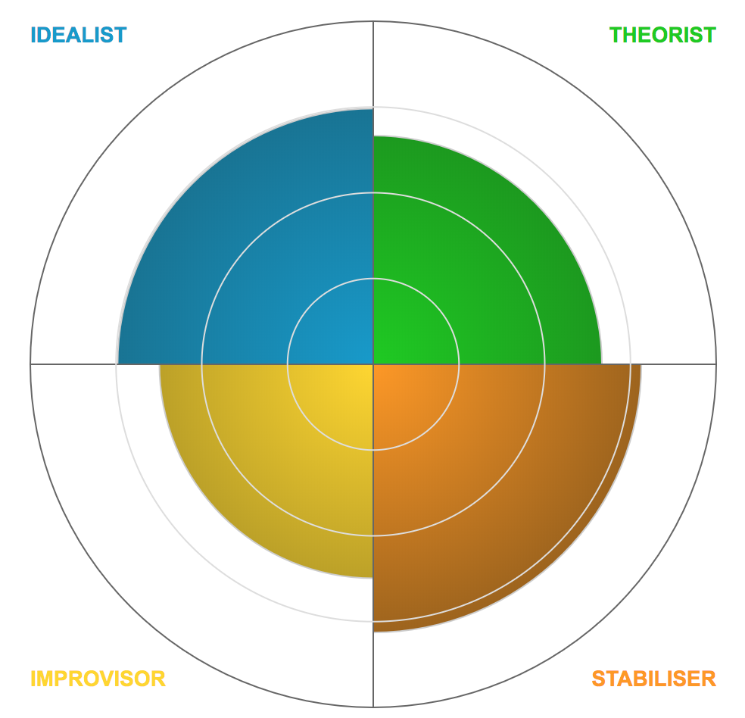

The category that I got the highest score in was stabilizer. Stabilizers value law and order so they like when clear rules and guidelines and they are driven by strong motivation. They are bound by a sense of duty to do the right thing which makes them sensible, responsible, and reliable.

They are said to be happiest when they are among like-minded people and when they demonstrate their standards to others. They also enjoy following-rules and co-operating with others.

They dream of wealth, status, and their influence on society, they value accountability and responsibility, and they dislike disobedience and cheating. It says that I am likely to be involved in business and commerce.

I don’t think that this is completely my personality but I do enjoy an element of order and following guidelines but I would not be interested in Business or commerce. I also consider myself to be more creative than how a stabilizer is described and I mostly enjoy making creative decisions.

Family Influence:

Both of my parent’s jobs were business based as my mother was a Human Resources Manager. My mom worked for an IT company and ensured that they followed the correct procedures and practices. She started a mentorship program, and recruited staff. She worked in Ireland, Europe and the UK as a part of a management team

My father was the head of ICT delivery in companies such as Dell and Digicel. He worked with the implementation of business solutions for major blue chip companies. In his work he had to communicate with his customers on a regular basis and he also worked in the recruitment side of the business.

However, my brother decided to become a tattoo artist and the other works in engineering. I think that the interests of my family relate to film production as I am creative like my brother and would like to work with set design, I enjoy working in teams like my father, and I also like to organize projects like my mother. All of these aspects have some relation to film production.

Even though both of my parents worked in an office environment, personally I do not think that this would be an ideal place to work for me. This is because I enjoy moving around and would not find it interesting to sit at a desk all day. I also like a change in scenery and could see myself losing motivation if I had to work in the same building for long hours.

A film producer that I really look up to is Kathleen Kennedy. She is an American film producer and she so-founded Amblin Entertainment with Steven Spielberg. She has worked on many successful films such as all of the Star Wars, Jurassic Park, E.T and many more. I have realized that the female producers do not get as much recognition as the male ones, and I think that this is something that must change.

Employment Trends:

Salaries: Starting salaries for assistant producers may range from about €20,000 to around €27,000 and with experience, these salaries may reach up to €40,000 to €55,000. Departmental heads can earn €60,000 to €80,000 plus benefits.

The salary for freelance producers may vary considerably depending on experience and whether you work on TV factuals, dramas, or feature films. Salaries will also differ depending on the size of the company and the project. Permanent jobs with companies are decreasing which may lead to financial insecurity. Employment for producers are regularly offers on a self-employed or dree-lance-contract basis.

Working Hours: This job involves regular unsocial hours at the weekends and evenings. Long hours of time spent in meetings or on location is normal. I was told that the long hours of this job may restrict someone’s social life when they are working on a large project. However, in this job you often get the chance to travel, meet new people, and many amazing opportunities.

Environment: The working environment of this profession is very inconsistent and often varies. They may spend a lot of time in an office or they may be based in a studio on location. Some negative aspects are that with all the travelling, you may be away from home for months at a time.

Interview

Q: What first inspired you to become a film producer?

A: Well when I was eight years old, I remember that my father bought me my first camera. I was interested in making short films from a very young age whether it was filming around my house or doing school projects. When I received this camera, my love for film making continued to grow. I decided that I wanted to be a part of the film industry, and I haven’t changed my mind since.

Q: What advice would you give to another film maker or producer preparing to produce their first project?

A:I would say that everyone who says you cant get it done, just ignore them immediately. You have to believe in yourself and your project. If it was easy, everyone would do it. The trail is covered with potholes and with people wanting you to wake up and “get a real job”. And I feel like half of what you’re trying to do is such a fantasy and is so difficult to do, that if you had any common sense you wouldn’t even try. But the other half is that some people don’t have faith in themselves and don’t believe that they are able to pull off these incredible things. I think that being a producer, you have to believe several impossible things when you get out of bed in the morning because the competition is very difficult and there are so many talented people in the industry. You have to be able to rise to the top of them and stay true to yourself.

Q: What are some of the common issues that a starting film producer will encounter?

A: Money is a major issue because raising money is very difficult. You should also be aware to define people’s role in the project. Because this may cause power struggles and internal struggles. It’s so important to decide who is the director and designers so that the entire project can run more smoothly. I believe you have to create an environment where people feel free to collaborate and where people can bring their point of view and talents to the table. It’s important to listen to all ideas.

Conclusion

After doing all this research, I am aware that film production is a difficult industry to succeed in and it requires a great amount of determination. However, this research has made it more apparent to me that this is a career that I would really like to pursue. I love how the work schedule changes every day and how it requires creative thinking. It is also necessary for people to work together cohesively, creating strong relationships with your co-workers. Another aspect of this career that excites me is the element of travel. Since travelling is something that I would love to do in the future, it would be great if it was incorporated into my job. However, I am very aware that money might be an issue in the early days of my career. This is because I would have to make investments into projects that may not always go to plan. Nevertheless, I have come to the realization that it is so important to choose a career that you love and that you are passionate about so that you can always be motivated to succeed. Personally, I am most motivated when doing things that I genuinely love and am most interested in.

