The Walt Disney Company: History

- Walter Elias Disney, the founder of the Walt Disney Company was a pioneer who wanted to develop the animation industry
- In October of 1923, the Disney Brothers Cartoon Studio was created by Walt and his brother Roy in Hollywood, California.
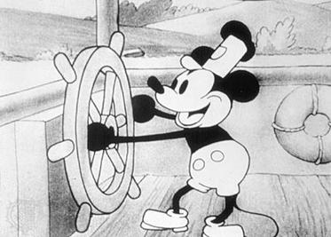
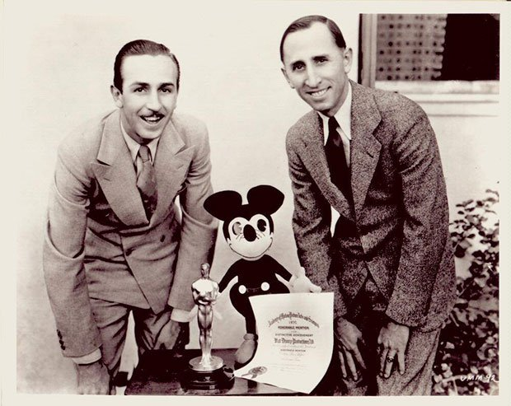

- As the company started to fail due to distribution rights, the creation of Mickey Mouse saved their company.
- In 1932 the creation of the cartoon called Silly Symphony earned the Disney Company their first academy award.
- Snow White and the Seven Dwarfs was released in 1937 and was ranked as the highest grossing films of the time.
- After their many successes, World War II halted the production of animations.
- When the war ended it was hard for the company to continue from where it left off.
- In 1955 a monumental event took place when the first Disney theme park was created, Disneyland.
- Walt died and Roy was left to take over the company

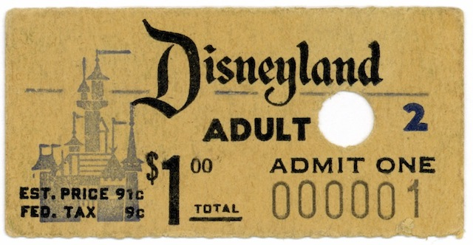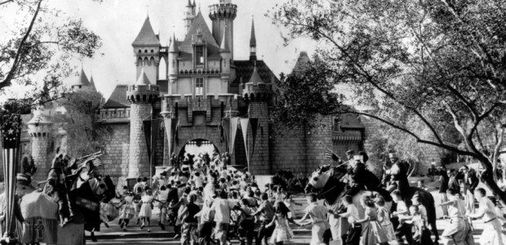

The Walt Disney Company: Growth

- Disney is now known as one of the most successful companies in the world, making about 5 billion dollars per year.
- There are 11 Disney lands in the world and they have on average 44,000 visitors in each park per day.
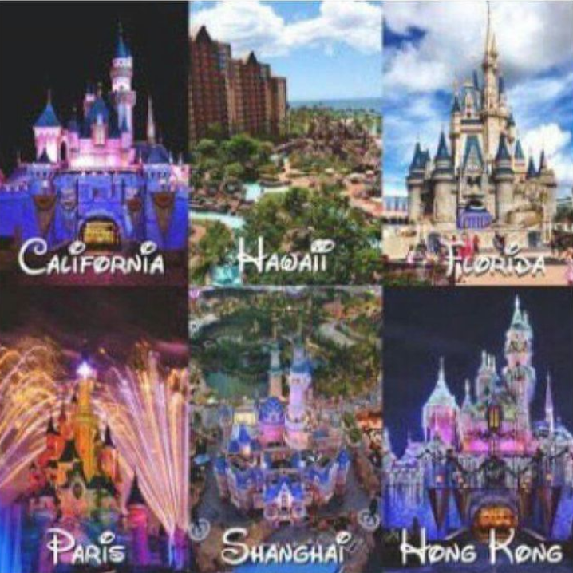
- In 1983 Disney created a television channel aimed at younger viewers. This channel showed both animations and human actors.
- It was necessary for the fans of the Disney animations to have merchandise, and now there are over 300 Disney stores in the world and also inline stores.
- The first every retail store opened in 1987.
- In 1998 the Disney Magic Cruise line was created and is now considered one of the best cruise lines.
- The company has reached the top of the world’s most reputable companies list and has been voted as the world’s most reputable brand.
- Over the past year, the company has received more than 150 prestigious awards.
- Disney has had such a large impact on the entertainment industry. This is because some of the most famous celebrities acted on Disney channel.
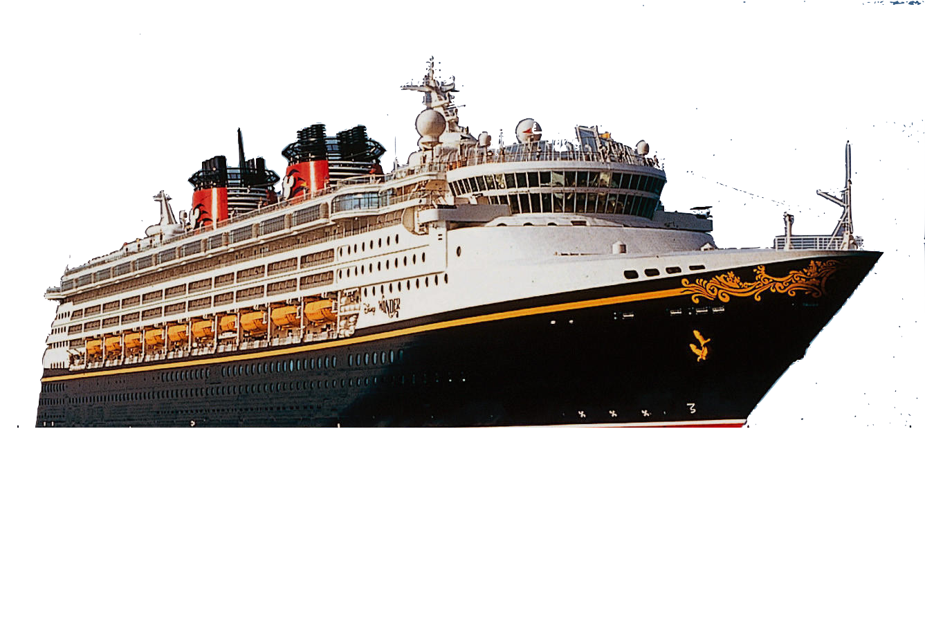
- These celebrities include: Selena Gomez, Demi Lovato, Zac Efron, Bryan Cranson, and Hilary Duff.
The Walt Disney Company: Development

How the company has branched out:

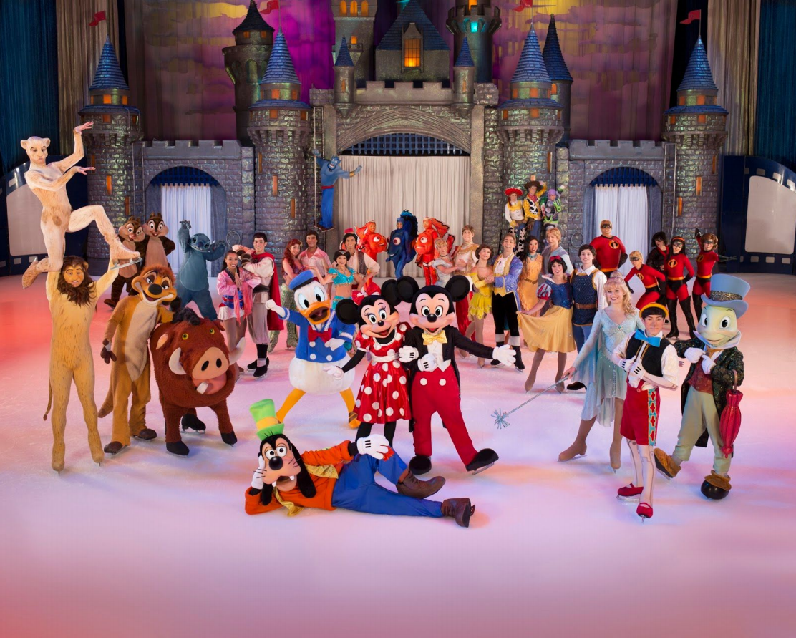
Subsidiaries (38):
- Pixar
- Walt Disney World
- Disney store
- Lucasfilm
- Marvel Studios
- Radio Disney
- Touchstone pictures
- Etc.

Games & Apps:
- Disney Mobile
- Gamestar
- Rocket Pack

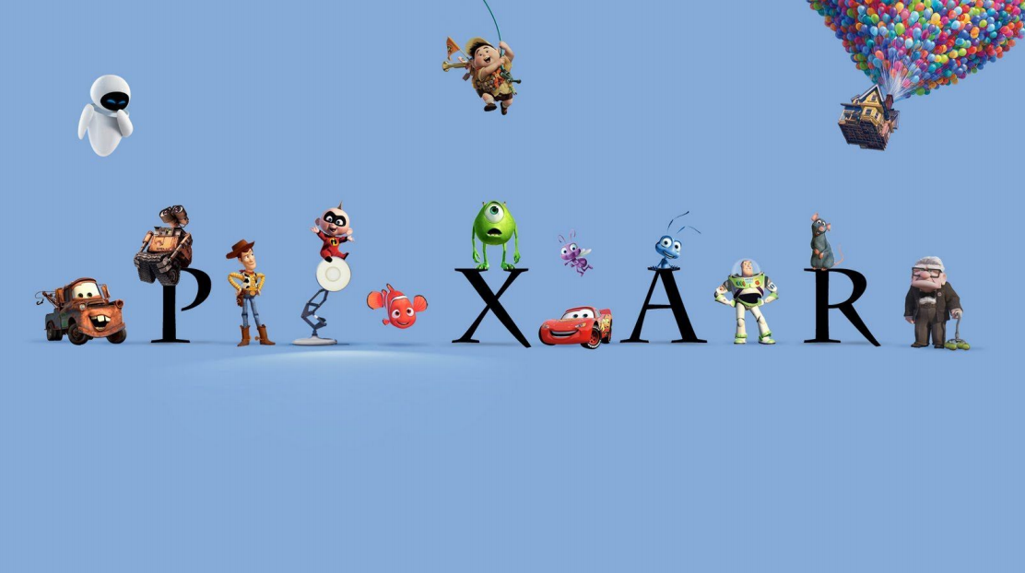
Retail:
- Stores in many continents including North America, Japan and Europe and Disney also have an online retail store

Theatrical Groups:
- Disney Theatrical Productions
- Disney Live Family Entertainment
■ Disney on Ice
■ Disney Live
- Walt Disney Special Events Group
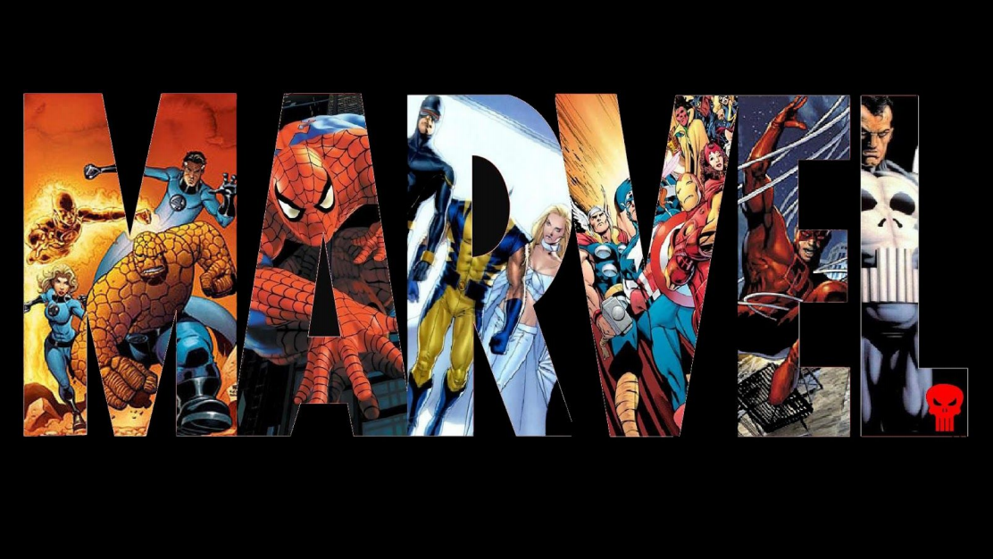
The Walt Disney Company: Sponsorship

Nestle
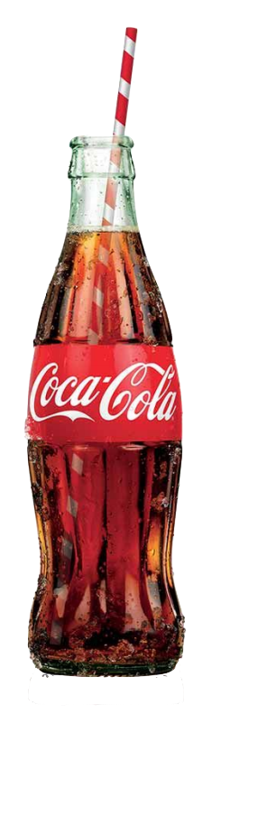
- Sponsors the Land Pavilion at Epcot and the stroller, pet care and baby care locations throughout the Walt Disney World property and Disneyland. Nestle also has presence in many of the food and beverage locations throughout those properties.

McDonald's
- Sponsors DinoLand at the Animal Kingdom and hosts fry cart throughout the parks at Walt Disney World and the Disneyland Resort. Also, operates restaurants at Downtown Disney and near the All - Star Resorts.

Kellogg's
- "The Official Sponsor of breakfast at the WDW Resort".

Coca Cola
- Provides soft drinks, water and juices to Walt Disney World and the Disneyland Resort. Also hosts Electric Umbrella, Cosmic Rays, Casey's Corner, Backlot Express, and Studio Catering. Dasani water also sponsors the Full and Half Marathon.

Haagen-Dazs
- Provides various ice cream products across Walt Disney World and Disneyland Resort.
